**QA role only for the following areas:**

Treated Water Samples, Entomology, Food Facility Risk Assessment

Process:

Once survey filled out, surveyor changes status to “Ready for QA”, clicks Save

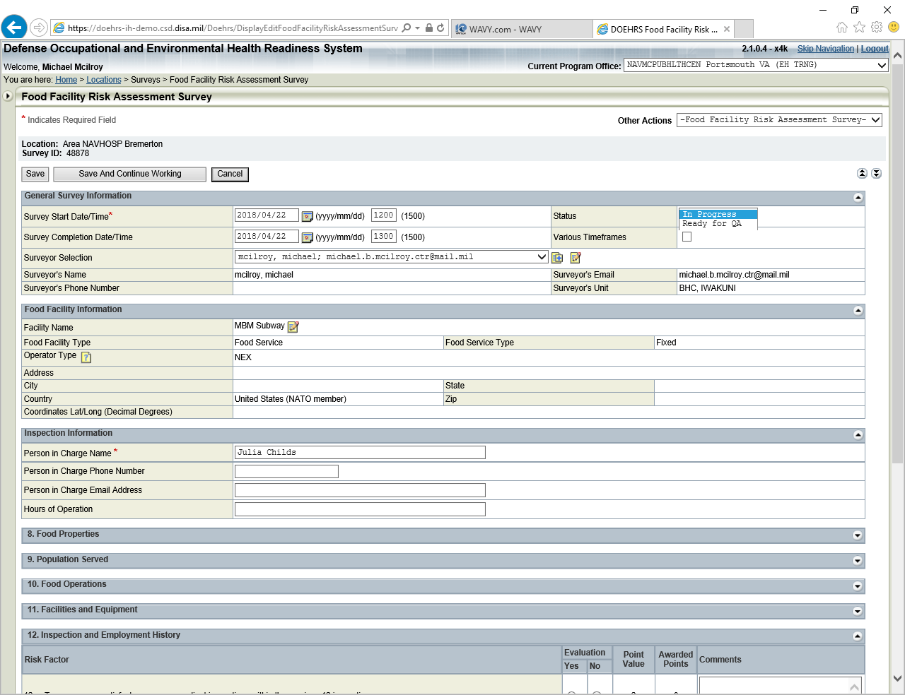

Choose Pending QA in Work Plan menu

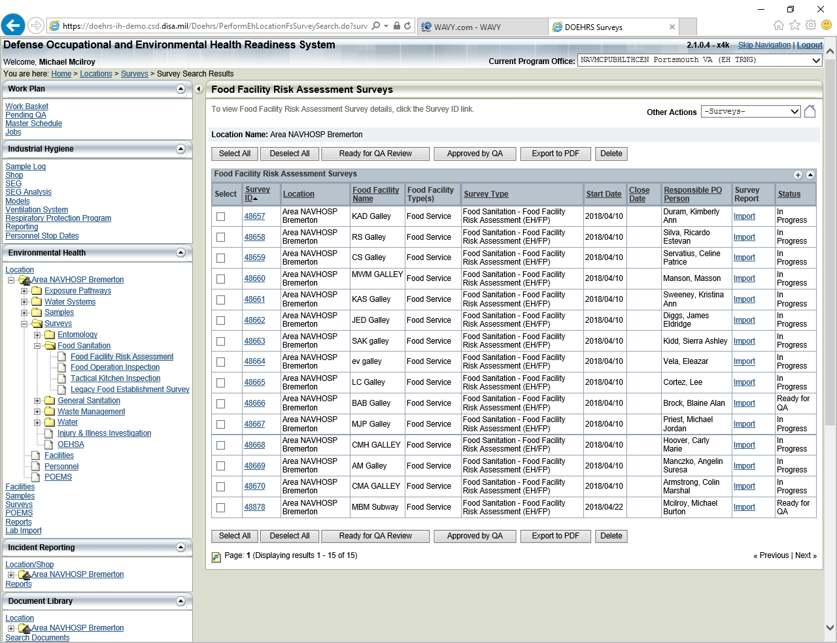

Pending QA Type – choose Environmental Health Surveys

Location Name – use the icon and browse the location tree, choose location

Click Search

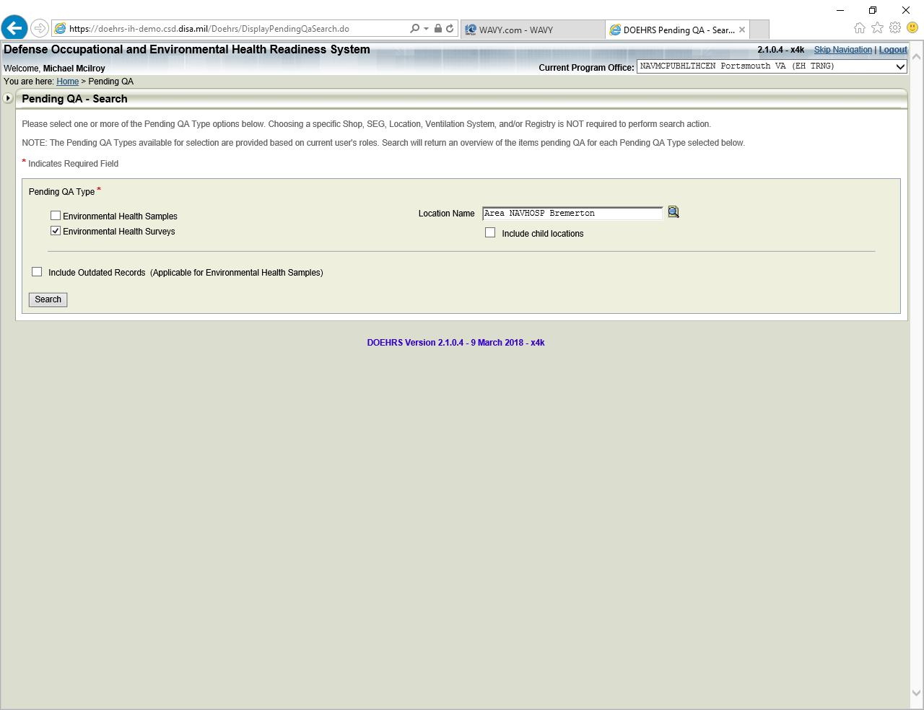

Number of QA ready items displayed, click on number

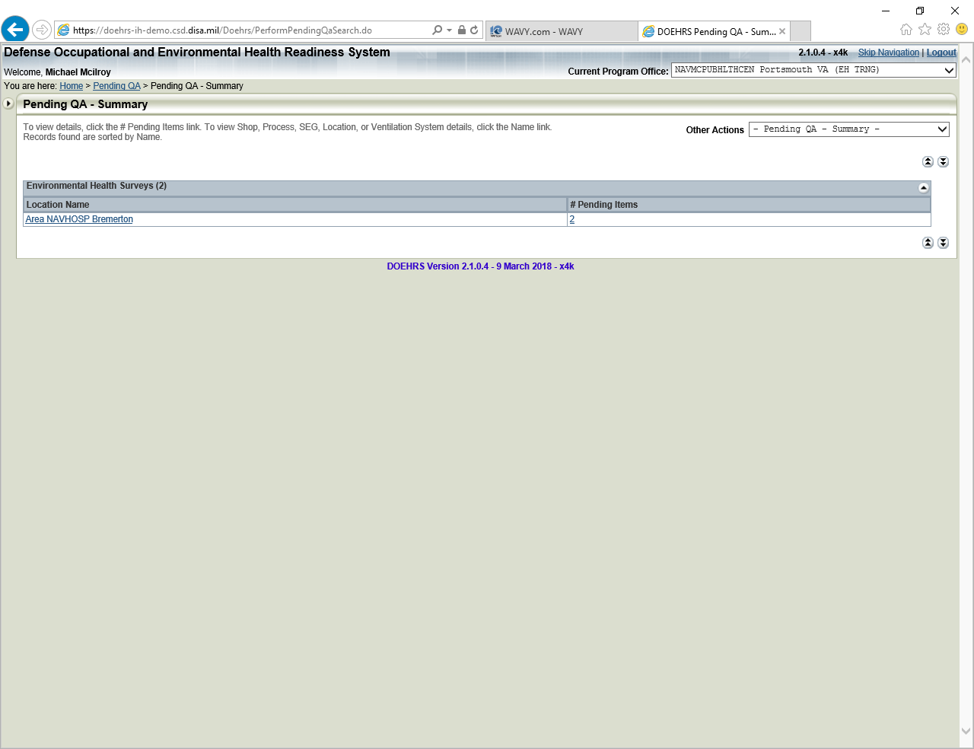

Surveys appear, select survey ID to conduct review

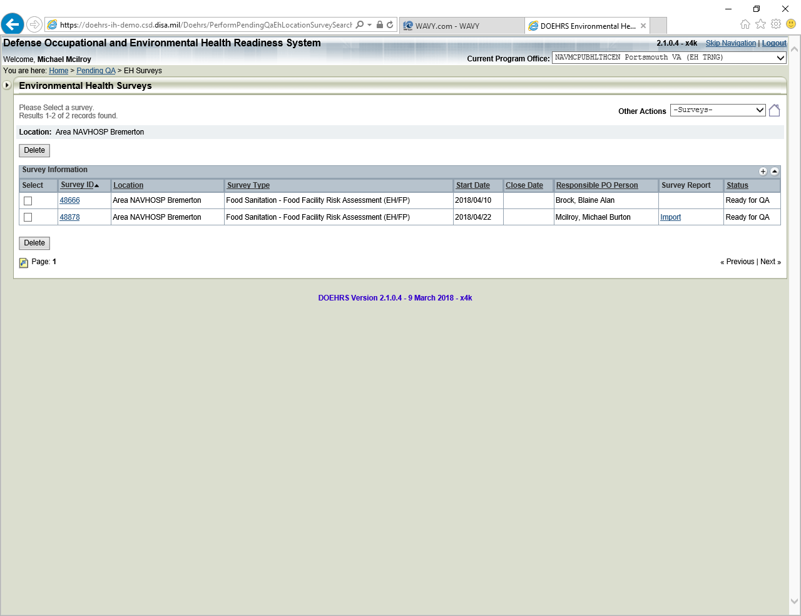

Conduct Review, can be marked “Approved by QA”, or if errors noted can be moved back to “In Progress”

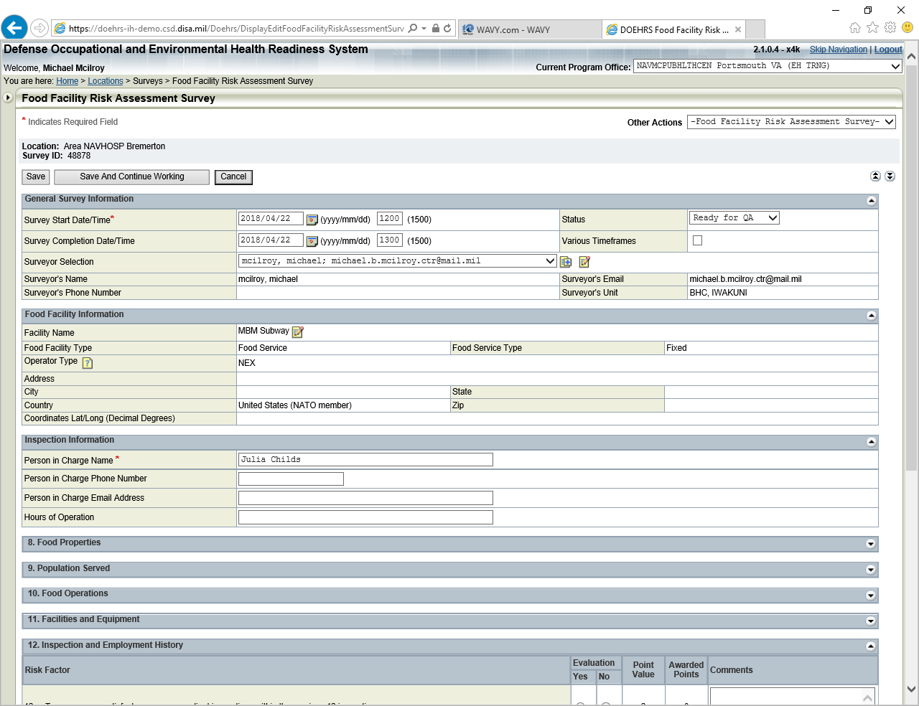

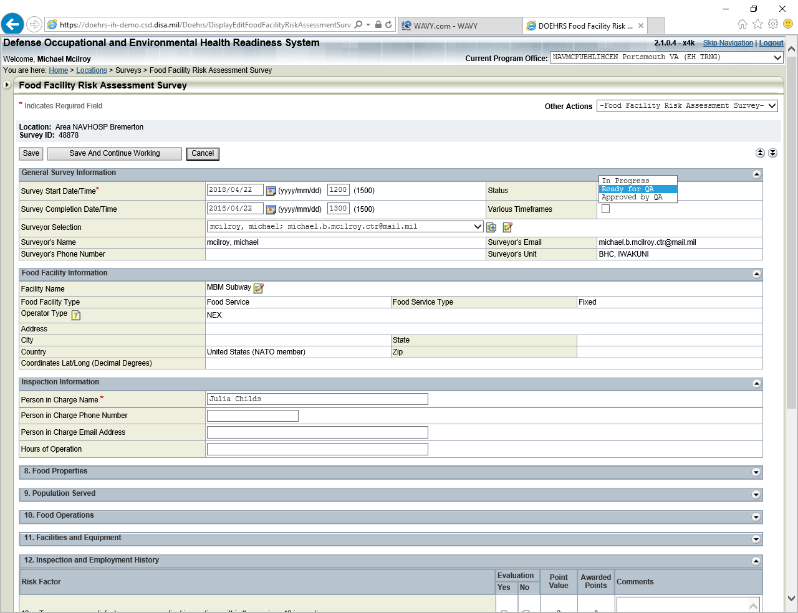

When status moved back to “In Progress”, a QA comments box appears allowing communication back to surveyor. Click Save

An email will be sent to surveyor by DOEHRS system letting them know of status change

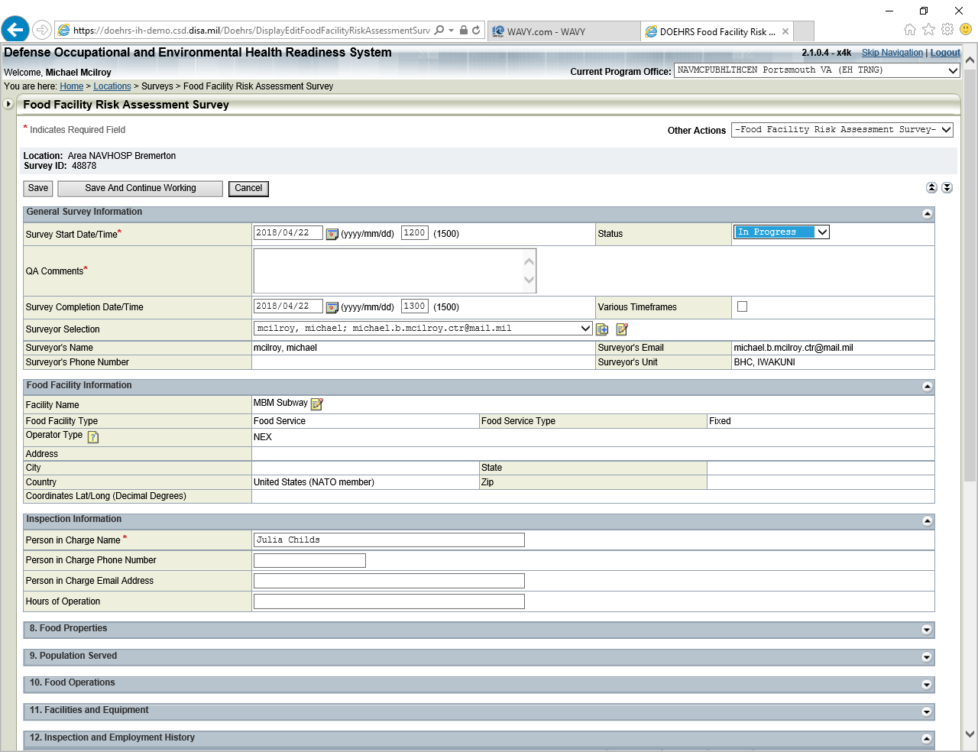

Once form has been marked “QA Approved” it is locked.